YCCE

Vision
“To become the most preferred institution providing innovative, research and value based, professional education for the society at large”.

Mission
YCCE is committed to
- Attract best talent and create learning ambience
- Practice Innovative teaching-learning & research
- Integrate Industry-Institute Collaborations
- Nurture students towards holistic development and choicest career

Department

Vision of the Department
To be a well-known center for pursuing computer education through innovative pedagogy, value-based education and industry collaboration.

Mission of the Department
To establish learning ambience for ushering in computer engineering professionals in core and multidisciplinary arena by developing problem-solving skills through emerging technologies.

23CT1402 | Lab: Operating Systems
Name of the Student: Anushka Yede | Semester/ Section: 5 A
Roll No: 01 | Enrollment Number: 23071016

Sr. No. | COs | POs |  |  |  |  |  |  |  |  |  |  |  | PSOs
 |  | Course Outcomes | 1 | 2 | 3 | 4 | 5 | 6 | 7 | 8 | 9 | 10 | 11 | PSO 1 | PSO2
1 | CO1 | Demonstrate the ability to execute Linux process management, memory management, and shell commands to manage system resources efficiently. | 3 | 3 | 3 | - |  | - | - | - | - | - | 3 | 3
2 | CO2 | Develop programs utilizing system calls, thread programming, and page replacement algorithms to simulate and analyze operating system functionalities. | 3 | 3 | 3 | - | - | - | - | - | - | - | 3 | 3
3 | CO3 | Design and implement process scheduling, memory allocation, and deadlock detection algorithms to address real-world operating system challenges. | 3 | 3 | 3 | - |  | - | - | - | - | - | 3 | 3
 |  | Avg |  | 3 | 3 | - |  | - | - | - | - | - | 3 | 3

Practical no 1
Aim: | Aim: Explore Configuration details of Computer System Hardware and Operating  System of your personal computer/Laptop with respect to -  a) Processor model  b) RAM size  c) Processor frequency  d) Cache memory size  e) SSD and HDD capacities  f) Operating system (32-bit or 64-bit)  g) Hyper-threading support: Indicate if the processor supports hyper-  threading and provide a brief explanation.
Theory | a) Processor Model  The processor model refers to the specific type of CPU used in your system, such as Intel Core i5-12400 or AMD Ryzen 7 5800H. It provides information about the CPU's generation, performance level, and manufacturer. This helps in comparing speed and features across different computers.  b) RAM Size  RAM (Random Access Memory) is the temporary working memory of your system, used to store active programs and data. It is measured in gigabytes (GB). More RAM allows smoother multitasking and better performance with large applications like games or video editors.  c) Processor Frequency  Processor frequency, measured in Gigahertz (GHz), indicates how many cycles the CPU can perform per second. For example, a 3.0 GHz processor can perform 3 billion cycles per second. Higher frequency generally means faster performance, though other factors like core count also matter.  d) Cache Memory Size  Cache memory is a small, very fast memory located within the CPU. It stores frequently accessed data and instructions to speed up processing. There are levels like L1, L2, and L3 cache, with L1 being the fastest but smallest. Larger cache sizes improve overall CPU efficiency.  e) SSD and HDD Capacities  Your system may have SSD (Solid State Drive) and/or HDD (Hard Disk Drive) for storage. SSDs are faster and more reliable, while HDDs offer more space at a lower cost. Storage is measured in gigabytes (GB) or terabytes (TB). For example, a system might have a 512GB SSD and a 1TB HDD.  f) Operating System (32-bit or 64-bit)  The operating system architecture determines how the system handles data and memory. A 64-bit OS can use more than 4GB RAM and run more powerful applications. Most modern computers run a 64-bit OS for better performance and software compatibility.  g) Hyper-threading Support  Hyper-threading is a technology (mainly by Intel) that allows a single physical CPU core to act like two logical cores, improving multitasking and performance in multi-threaded tasks. If your processor supports hyper-threading, it can handle more processes at once, making the system more efficient.
Asus TUF F17 (2022) Laptop

- Display: 17.3″ Full HD (1920×1080) with 144 Hz refresh rate
- Processor: Intel Core i7-12700H (12th gen)
- RAM: 16 GB (expandable up to 32 GB)
- Graphics: NVIDIA GeForce RTX 3060 with 6 GB GDDR6 memory
- Storage: No HDD; comes with SSD storage (unspecified)
- Operating System: Windows 11
- Connectivity & Ports: Wi-Fi 6 (802.11ax), Bluetooth 5.2, Ethernet, 2× USB 3.2 Gen-1 Type-A, 1× Thunderbolt 4 (Type-C), HDMI, RJ45 LAN
- Battery: 90 Wt

Realme 9 Pro 5G Smartphone

- Display: 6.6″ IPS LCD, 1080×2412 resolution, 120 Hz refresh rate, 240 Hz touch sampling
- Processor: Qualcomm Snapdragon 695 (8 nm), Octa-core up to 2.2 GHz, Adreno 619 GPU
- RAM & Storage: 6 GB or 8 GB RAM with 128 GB UFS 2.2 storage
- Battery & Charging: 5000 mAh battery, Dart Charge 33 W fast charging
- Cameras:
  - Rear: 64 MP (wide) + 8 MP (ultrawide) + 2 MP (macro)
  - Front: 16 MP selfie camera
- Software: Android 12 with Realme UI 3.0 (upgradeable)
- Dimensions & Weight: ~164.3 × 75.6 × 8.5 mm, ~195 g

Acer Computer with Ryzen 7 Processor

There are several PC models that meet this criterion. A notable one is:
Acer Aspire XC-1760 Desktop with Ryzen 7 5700G
- Description: A compact desktop featuring AMD Ryzen 7 5700G APU.
Another related example within Acer’s laptop segment is the new Swift Go AI series:
Acer Swift Go AI (14 & 16) Laptops
- Processor: AMD Ryzen AI 7 350 (8 cores, 16 threads, up to 5.0 GHz boost)
- Memory: Supports up to 32 GB DDR5X SDRAM
- Graphics: Integrated Radeon 800M; includes NPU for AI tasks
- Battery Life: Up to 24.9 hours on the Swift Go 14 AI; up to 18 hours on the Swift Go 16 AI

Output: | Computer –  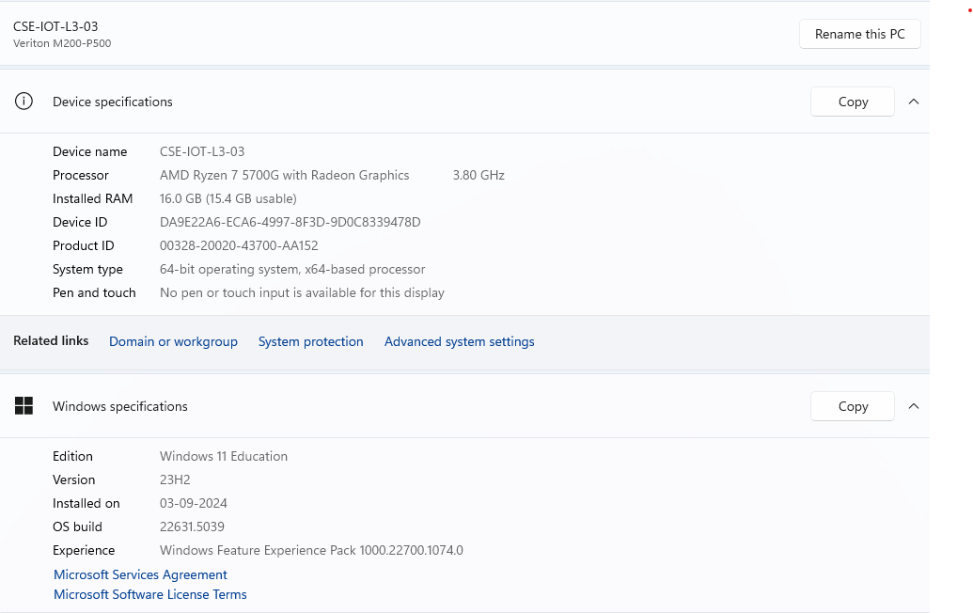  Laptop-  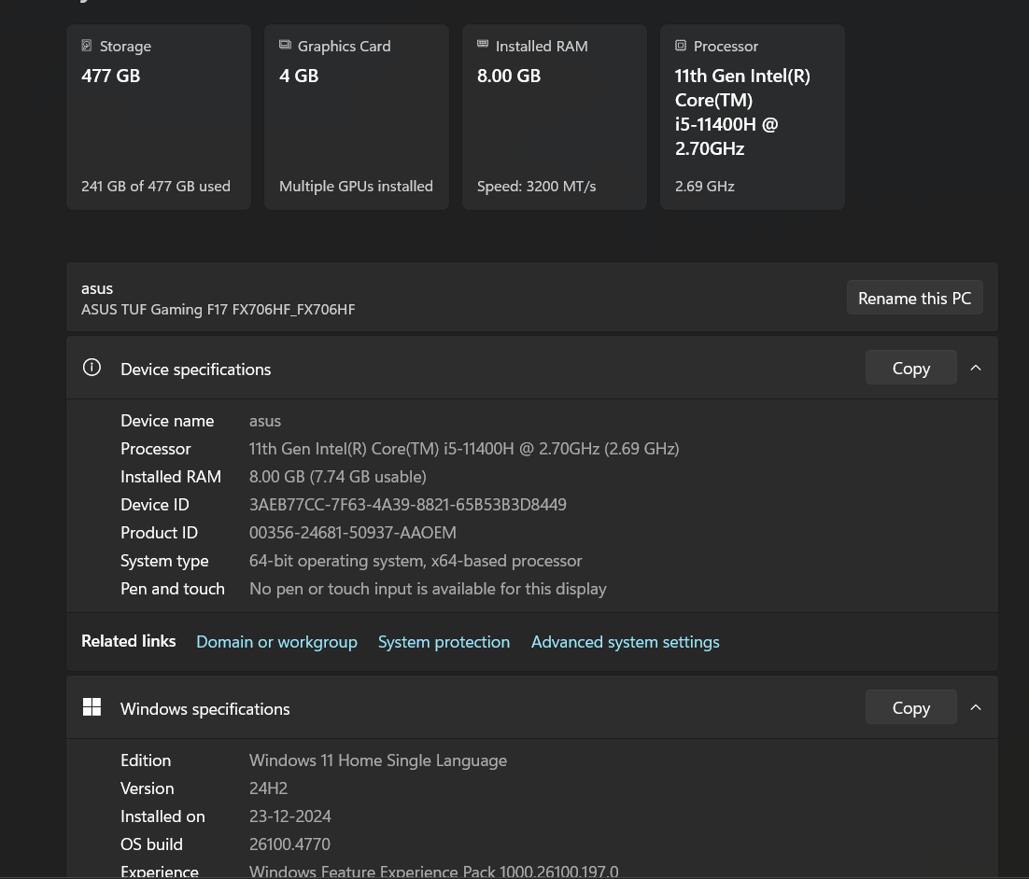  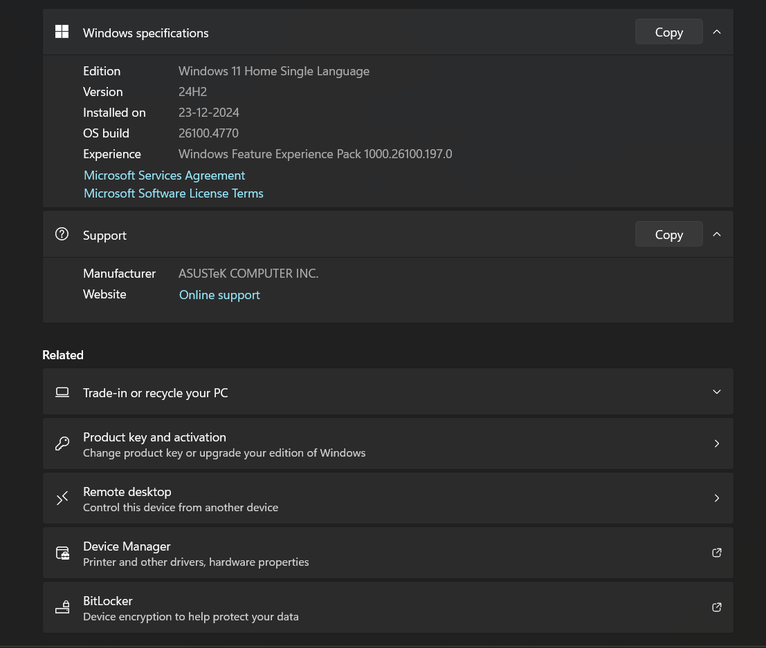  Phone-  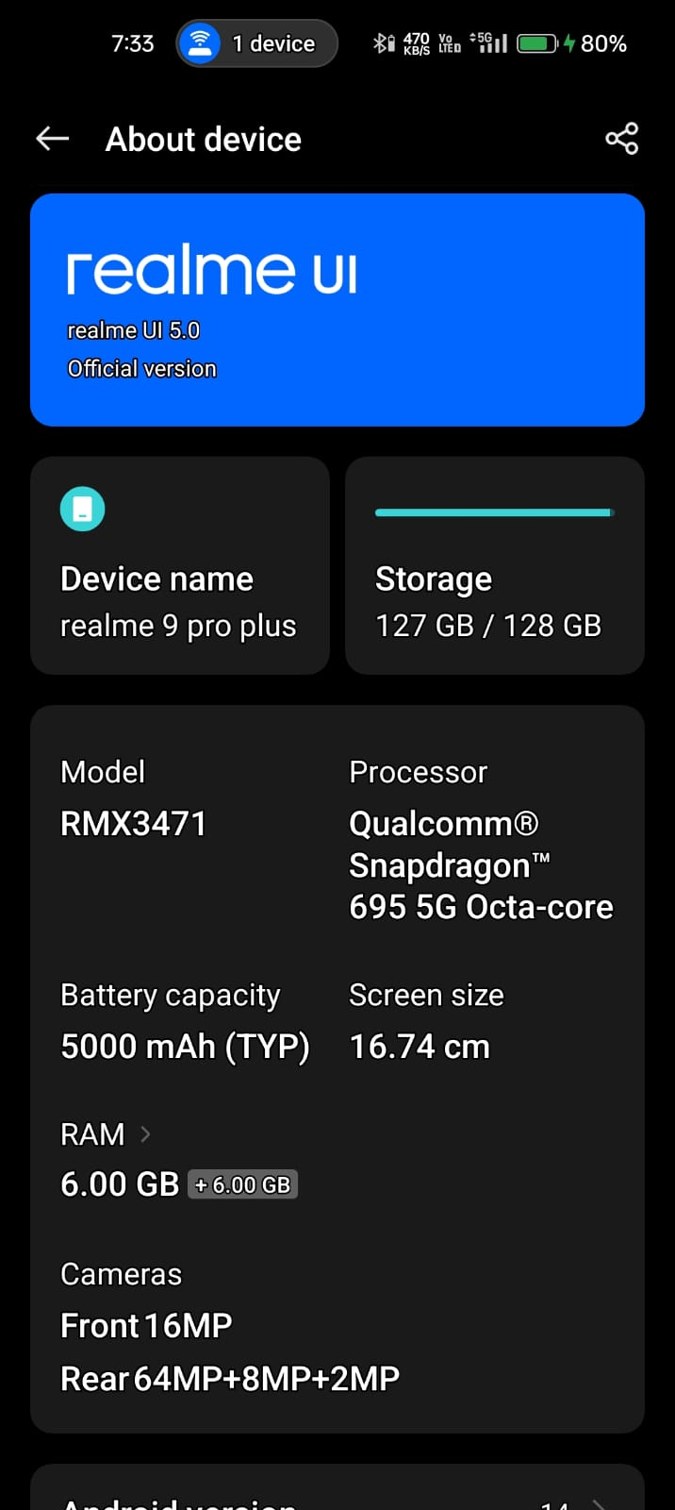
Conclusion | Explore Configuration details of Computer System Hardware and Operating system is done successfully.

